How to write a CV
Overview
Available jobs are often advertised on the internet or in newspapers. A job ad is also called a job posting. Candidates are expected to send their CV and covering (motivational) letter. After a candidate is short-listed they are invited to a job interview.
A CV (AmE a resumé) is a document that represents your career biography. It is important the CV reflects your education, skills and work experience truthfully. Its visual appearance should be neat and clear. It is a good idea to include a photo of yourself in a business environment. A CV should be written carefully without grammar or spelling mistakes. At the end of your CV you should include one or two referees who can confirm the truthfulness of your statements and these are usually your teachers or former employers. Here is the list of information you are expected to cover in your CV:
- Basic info (name, date of birth, address, e-mail address, phone number)
- Your personal profile/personal statement/summary (one sentence that sums up your qualifications, skills and motivation in career development)
- Qualifications/ education (list your qualifications in reverse chronological order, so that the last is listed first)
- Work experience (in reverse chronological order)
- Skills (language skills, computer skills, driving licence)
- Interests and hobbies
- Referees (e-mails of credible people who can confirm your qualities, such as your teachers or previous employers)
Young people with little or no work experience can present their volunteer work, membership in clubs and societies or other achievements relevant for the position such as participation in competitions or various awards in the field of sport or education.
Reading
Read the advertisement posted on the internet for the position of a receptionist and reservation staff.
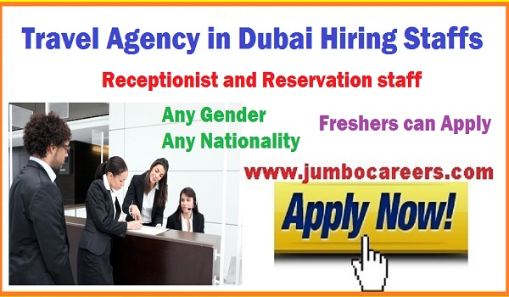
Read a sample CV that can be submitted to the company.
ANA MARKOVIC
20 March 2001

9 Mutapova Street
Belgrade, 11000
Serbia

ana.markovic@gmail.com
+38162123456
Summary: An enthusiastic, communicative and well-organized student with excellent foreign language skills.
EDUCATION
- COLLEGE OF TOURISM, Belgrade (October 2020-)
Bachelor’s Degree in Applied Economics In Tourism, expected 2023
WORK EXPERIENCE
- ABC HOSTEL, Belgrade
Summer Intership (August 2019)

- DELFI BOOKSTORE CAFE, Belgrade
Waitress (June-July 2019)

- BELDOCS Festival of documentary films, Belgrade
Volunteer (May 2018)

SKILLS
Language skills:
Serbian (Mother tongue)
English ( C1)
German (B2)
Spanish (B2)

Computer Skills:
Microsoft Office, Power Point, Excel
Skype

INTERESTS
Basketball
National Folk Dance

Listening
Watch the video CV for students with no experience on the following link
https://www.youtube.com/watch?v=aArb68OBFPg
How can Ana Markovic`s CV from the Reading section be improved using the tips from the video? Has Ana left out some heading?
Writing
Using all that you learnt in this lesson write two versions of your CV. One version should be submitted to a company that is looking for children`s animator in a seaside resort, while the other version should be submitted to a hotel looking for receptionist assistent. Think about possible differences in the profile section of your CV.

